**Name:** Trần Minh Quân

**ID**: 19151078

Midterm Test

1. Hardware

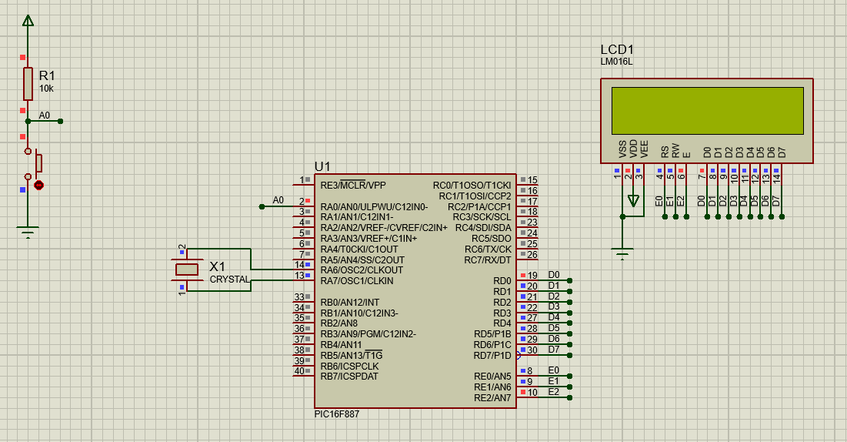

1. Code
2. Mode 1

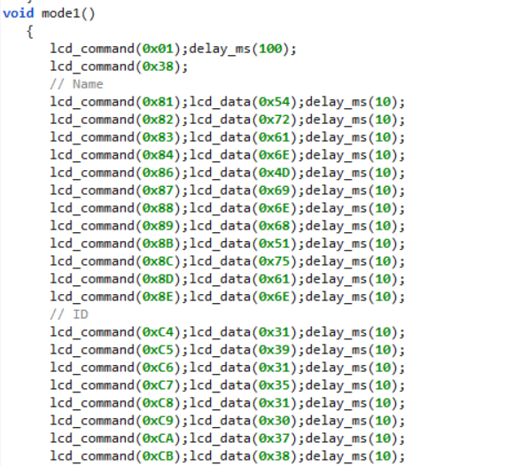

Figure : Display Name and ID

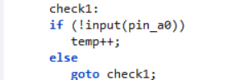

Figure : Check if button press? In mode 1

1. Mode 2

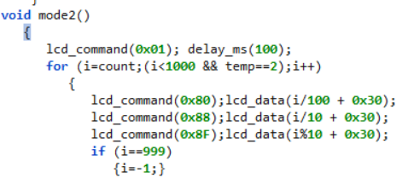

Figure : Count up and display in LCD

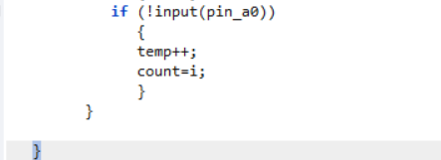

Figure : Check if press? in mode 2

1. Mode 3

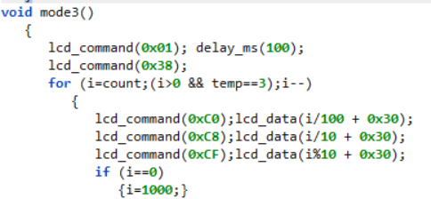

Figure : Count down and display

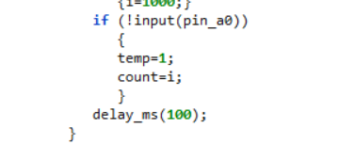

Figure :Check if press? in mode 3

1. Main

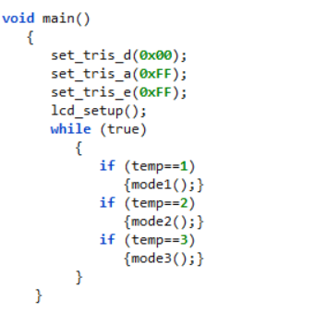

Figure :Main

1. Flow chart

